Cisco CCNP Lab 9: MPLS

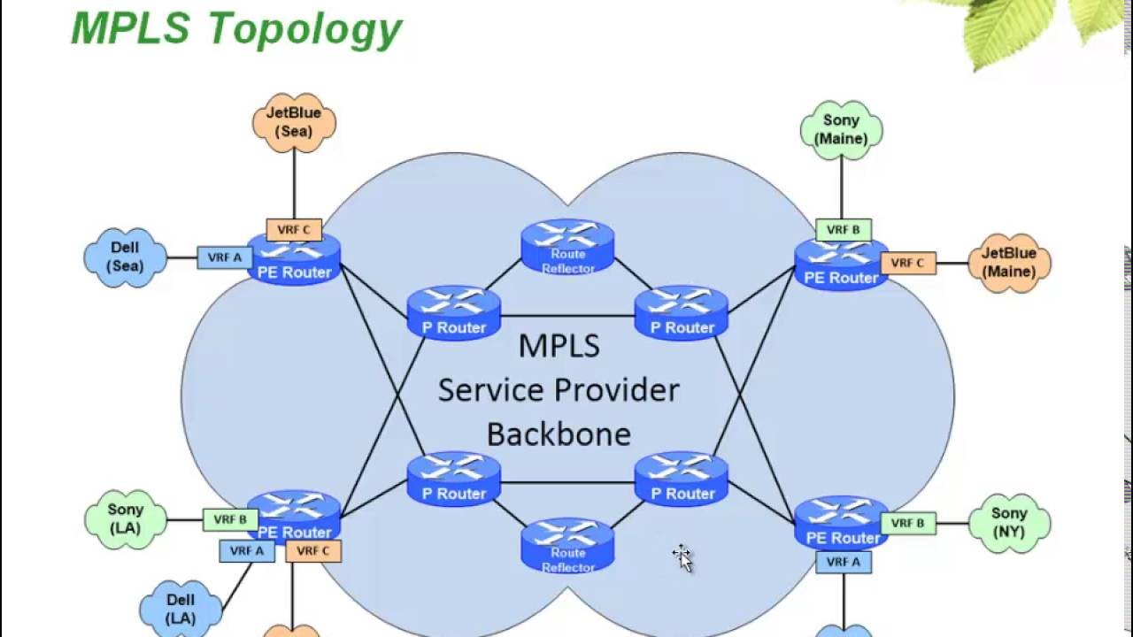

The purpose of this lab was to teach us how to use MPLS. MPLS is a tool to route packets, but instead of using networking addresses, MPLS uses labels. While doing the lab seemed to just be setting up OSPF and adding a couple of extra commands, MPLS is far more complicated than that.

First some background. **M**ulti**p**rotocol **L**abel **S**witching is a protocol that finds the shortest path. However, instead of using network addresses, it uses “labels,” hence the name, **label** switching. While researching what OSI layer MPLS uses, I noticed an interesting answer. MPLS uses layer “2.5” because it operates at both layer 2 and layer 3. But to explain how everything works, I will have to explain how traditional routings works, then how MPLS routing works

Traditionally, when something is sent over the internet, it gets broken up into packets. Each packet has a header, trailer, and the actual data between them. The receiving device then assembles each packet together to recreate the whole thing. If, for example, an email is sent, then the email is divided into packets, carried to the receiving device, then reassembled to the original email. One key part of a packet is its destination IP address. Just like how mail has a physical destination address to send all of it to your grandmother, a packet has a destination IP address to send to your Norwegian friend. Now, to get a packet from its source to its destination, the packet must hop from one router to the next. So how does that work? Each router on the internet has its own routing table. When a router receives a packet, it tries to figure out where to send it using its routing table. Then the packet is forwarded through what the router thinks is the best network. Each time the packet is sent to another router, the next router must do the same thing. This can lead to some issues though. One notable problem is that because each router has a routing table separate from all the other routers, different packets with the same destination IP address may take a slightly different route. This is because if a router decides to update (and thus potentially change) its routing table, a packet may go a different route. This could lead to some packets taking longer to reach its destination than other packets. If several packets are using UDP and the first packet takes longer than its subsequent packets, then they could arrive out of order and UDP would make no attempt to fix it. Also, moving across different routes means that some packets could get stuck in loops and eventually get dropped. Again, with UDP, this means some packets (like voice) could get lost and would never show up again. Also, some people just want to control where their packets go so they can arrive on the same path as fast as possible. This is where MPLS comes in.

MPLS works very differently. Routers in traditional routing have their own separate routing table (and thus must make decisions independently of each other), which can lead to packets going from the same source IP to the same destination IP taking different paths. With MPLS, these packets would take the exact same path every time. To do this, MPLS uses the **l**abel **d**istribution **p**rotocol to make and exchange labels between routers. MPLS assigns each packet a **f**orwarding **e**quivalence **c**lass, which then takes a **l**abel-**s**witched **p**ath (a path made by LDP). Depending on the packet’s FEC class, it will be assigned to a specific LSP. Every packet with the same FEC will follow the same LSP. So, what happens if a packet has more than one label attached to it? MPLS solves this by making its own header on top of the packet’s own header. There it contains the packet’s FECs when routers look at the packet, it will first read the MPLS header and determine what path the packet should take. Now note that the router doesn’t look at the destination IP address; it doesn’t need to. Because each FEC already tells where all the packets are sent to, the router can ignore the IP header and direct the packet through the right LSP. Best part? MPLS can work with almost any protocol (hence the **multiprotocol** in MPLS). This is because all the router needs to read is the MPLS labels at the front of the packet. The rest of the packet can be formatted in virtually any way, but the front is all that truly matters.

While this does make MPLS better than traditional routing in many ways, there are several big downsides. The most obvious is cost. MPLS is often significantly more expensive than regular internet service. Part of the reason is that only some routers support MPLS, routers that don’t can’t use it. Also, the extra time to manually configure the LSPs, especially on large networks, can be a pain and could take a long time. This, by extension, means that MPLS isn't very scalable. Finally, MPLS is not like a VPN, so traffic is not encrypted. Any attacker who can intercept any packets on MPLS paths could read them in plaintext, so encryption must be set up separately.

If we already have a comprehensive routing system and MPLS has major drawbacks, when would we want to use it? MPLS is most often used for real-time applications, the most well-known of which are voice and video. Voice and video traffic need to be fast and reliable, and MPLS satisfies both. And while MPLS can be used to set up WANs, they can be expensive and hard to scale as said earlier.

While this is all cool, why is MPLS a layer “2.5” protocol and not layer 2 or 3? MPLS tells routers how to read the labels, not the actual IP address of packets. Remember, LDP is layer 2 and generates the labels that routers will use. Routers then take the path that was set up, which is layer 3. This means that MPLS is using some of both layers 2 and 3, which is why it’s described to be a layer 2.5 protocol.

In summary, I set up OSPF on 5 devices (2 routers and 3 multilayer switches), set up MPLS on the 3 switches, and had them all communicate with each other within their networks, as well as allowing traffic to travel across all networks.

Here is the network diagram that was conveniently laid out for me to use:

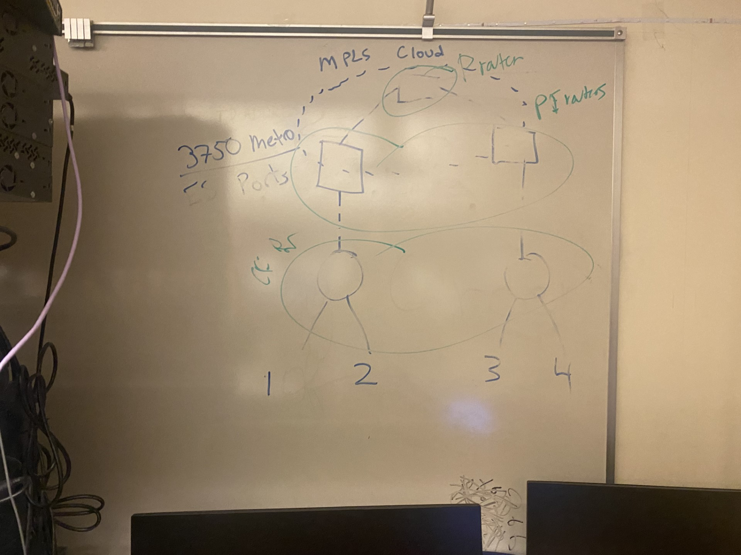

Here are the new commands I needed to get MPLS to work:

mpls label protocol ldp: enables MPLS LDP globally

interface [interface]:

mpls ip: enables MPLS on the interface

show mpls forwarding-table: shows the forwarding table for MPLS, which reveals the labels on local and outgoing routes

Here is the running configs of all the routers and multilayer switches

Router 1:

R1#show run

Building configuration...

Current configuration : 1461 bytes

Last configuration change at 19:18:56 UTC Wed May 24 2023

version 15.5

service timestamps debug datetime msec

service timestamps log datetime msec

no platform punt-keepalive disable-kernel-core

hostname R1

boot-start-marker

boot-end-marker

vrf definition Mgmt-intf

address-family ipv4

exit-address-family

address-family ipv6

exit-address-family

no aaa new-model

subscriber templating

vtp domain cisco

vtp mode transparent

multilink bundle-name authenticated

license udi pid ISR4321/K9 sn FDO214421CF

spanning-tree extend system-id

redundancy

mode none

vlan internal allocation policy ascending

vlan 10,20

interface Loopback0

ip address 10.0.10.1 255.255.255.0

ip ospf 1 area 0

interface GigabitEthernet0/0/0

ip address 10.0.0.1 255.255.255.0

ip ospf 1 area 0

negotiation auto

interface GigabitEthernet0/0/1

ip address 10.0.1.1 255.255.255.0

ip ospf 1 area 0

negotiation auto

interface Serial0/1/0

no ip address

interface Serial0/1/1

no ip address

interface GigabitEthernet0

vrf forwarding Mgmt-intf

no ip address

negotiation auto

interface Vlan1

no ip address

router ospf 1

network 10.0.0.0 0.255.255.255 area 0

ip forward-protocol nd

no ip http server

no ip http secure-server

ip tftp source-interface GigabitEthernet0

control-plane

line con 0

stopbits 1

line aux 0

stopbits 1

line vty 0 4

login

end

R1#show ip route

Codes: L - local, C - connected, S - static, R - RIP, M - mobile, B - BGP

D - EIGRP, EX - EIGRP external, O - OSPF, IA - OSPF inter area

N1 - OSPF NSSA external type 1, N2 - OSPF NSSA external type 2

E1 - OSPF external type 1, E2 - OSPF external type 2

i - IS-IS, su - IS-IS summary, L1 - IS-IS level-1, L2 - IS-IS level-2

ia - IS-IS inter area, * - candidate default, U - per-user static route

o - ODR, P - periodic downloaded static route, H - NHRP, l - LISP

a - application route

+ - replicated route, % - next hop override, p - overrides from PfR

Gateway of last resort is not set

10.0.0.0/8 is variably subnetted, 11 subnets, 2 masks

C 10.0.0.0/24 is directly connected, GigabitEthernet0/0/0

L 10.0.0.1/32 is directly connected, GigabitEthernet0/0/0

C 10.0.1.0/24 is directly connected, GigabitEthernet0/0/1

L 10.0.1.1/32 is directly connected, GigabitEthernet0/0/1

O 10.0.2.0/24 [110/4] via 10.0.1.2, 00:05:03, GigabitEthernet0/0/1

O 10.0.3.0/24 [110/5] via 10.0.1.2, 00:04:26, GigabitEthernet0/0/1

C 10.0.10.0/24 is directly connected, Loopback0

L 10.0.10.1/32 is directly connected, Loopback0

O 10.0.20.1/32 [110/5] via 10.0.1.2, 00:04:26, GigabitEthernet0/0/1

O 10.1.0.0/24 [110/2] via 10.0.1.2, 00:05:03, GigabitEthernet0/0/1

O 10.2.0.0/24 [110/3] via 10.0.1.2, 00:05:03, GigabitEthernet0/0/1

R1#

Router 2:

R2#show run

Building configuration...

Current configuration : 1409 bytes

Last configuration change at 19:34:39 UTC Wed May 24 2023

version 15.5

service timestamps debug datetime msec

service timestamps log datetime msec

no platform punt-keepalive disable-kernel-core

hostname R2

boot-start-marker

boot-end-marker

vrf definition Mgmt-intf

address-family ipv4

exit-address-family

address-family ipv6

exit-address-family

no aaa new-model

subscriber templating

multilink bundle-name authenticated

license udi pid ISR4321/K9 sn FDO211216BL

spanning-tree extend system-id

redundancy

mode none

vlan internal allocation policy ascending

interface Loopback0

ip address 10.0.20.1 255.255.255.0

ip ospf 1 area 0

interface GigabitEthernet0/0/0

ip address 10.0.3.1 255.255.255.0

ip ospf 1 area 0

negotiation auto

interface GigabitEthernet0/0/1

ip address 10.0.2.2 255.255.255.0

ip ospf 1 area 0

negotiation auto

interface Serial0/1/0

no ip address

interface Serial0/1/1

no ip address

interface GigabitEthernet0

vrf forwarding Mgmt-intf

no ip address

negotiation auto

interface Vlan1

no ip address

router ospf 1

network 10.0.0.0 0.255.255.255 area 0

ip forward-protocol nd

no ip http server

no ip http secure-server

ip tftp source-interface GigabitEthernet0

control-plane

line con 0

stopbits 1

line aux 0

stopbits 1

line vty 0 4

login

end

R2#show ip route

Codes: L - local, C - connected, S - static, R - RIP, M - mobile, B - BGP

D - EIGRP, EX - EIGRP external, O - OSPF, IA - OSPF inter area

N1 - OSPF NSSA external type 1, N2 - OSPF NSSA external type 2

E1 - OSPF external type 1, E2 - OSPF external type 2

i - IS-IS, su - IS-IS summary, L1 - IS-IS level-1, L2 - IS-IS level-2

ia - IS-IS inter area, * - candidate default, U - per-user static route

o - ODR, P - periodic downloaded static route, H - NHRP, l - LISP

a - application route

+ - replicated route, % - next hop override, p - overrides from PfR

Gateway of last resort is not set

10.0.0.0/8 is variably subnetted, 11 subnets, 2 masks

O 10.0.0.0/24 [110/5] via 10.0.2.1, 00:04:56, GigabitEthernet0/0/1

O 10.0.1.0/24 [110/4] via 10.0.2.1, 00:04:56, GigabitEthernet0/0/1

C 10.0.2.0/24 is directly connected, GigabitEthernet0/0/1

L 10.0.2.2/32 is directly connected, GigabitEthernet0/0/1

C 10.0.3.0/24 is directly connected, GigabitEthernet0/0/0

L 10.0.3.1/32 is directly connected, GigabitEthernet0/0/0

O 10.0.10.1/32 [110/5] via 10.0.2.1, 00:04:56, GigabitEthernet0/0/1

C 10.0.20.0/24 is directly connected, Loopback0

L 10.0.20.1/32 is directly connected, Loopback0

O 10.1.0.0/24 [110/3] via 10.0.2.1, 00:04:56, GigabitEthernet0/0/1

O 10.2.0.0/24 [110/2] via 10.0.2.1, 00:04:56, GigabitEthernet0/0/1

R2#

Multilayer Switch 1:

MLS1#show run

Building configuration...

Current configuration : 3504 bytes

version 12.2

no service pad

service timestamps debug datetime msec

service timestamps log datetime msec

no service password-encryption

hostname MLS1

boot-start-marker

boot-end-marker

no aaa new-model

system mtu routing 1500

ip routing

vtp domain cisco

vtp mode transparent

mpls label protocol ldp

crypto pki trustpoint TP-self-signed-3180753792

enrollment selfsigned

subject-name cn=IOS-Self-Signed-Certificate-3180753792

revocation-check none

rsakeypair TP-self-signed-3180753792

crypto pki certificate chain TP-self-signed-3180753792

certificate self-signed 01

3082023C 308201A5 A0030201 02020101 300D0609 2A864886 F70D0101 04050030

31312F30 2D060355 04031326 494F532D 53656C66 2D536967 6E65642D 43657274

69666963 6174652D 33313830 37353337 3932301E 170D3933 30333031 30303031

30315A17 0D323030 31303130 30303030 305A3031 312F302D 06035504 03132649

4F532D53 656C662D 5369676E 65642D43 65727469 66696361 74652D33 31383037

35333739 3230819F 300D0609 2A864886 F70D0101 01050003 818D0030 81890281

8100B156 0AFAA3C0 BD78BF1E 4850D091 3ABE2299 7DA8179F 1FC2DC96 95BF605A

1B125E4B E90807FE 06675987 9744890D 551C16F5 4A8A7A8A E5EAE48D 103E22CF

5C0FA067 4AFECB94 15200FDC 0039FC9C D3A256DF 2F0534A4 6EF16256 78CC2359

53F2BF2E C58E1A46 B1617227 8F54DA0D 5847D7C6 5013ACB4 EA98F5DA 63D996FE

68C10203 010001A3 64306230 0F060355 1D130101 FF040530 030101FF 300F0603

551D1104 08300682 044D4C53 31301F06 03551D23 04183016 8014B540 C2371C1A

9C7DEC4C 58675B46 C5257FC7 2BC4301D 0603551D 0E041604 14B540C2 371C1A9C

7DEC4C58 675B46C5 257FC72B C4300D06 092A8648 86F70D01 01040500 03818100

AAE10AB9 BEE35226 B0557CC7 FE210A8A E0EAD13C E93AF1A7 0D0FBE2B 2406320A

7E1B0983 94F40D52 24622B91 7504FF83 A01DB15D 0BD3A111 A854CDAF ED6CD97F

75B8DE00 2AA71C74 AFF5AD4C 20C12958 FC3824D4 0486DA7D B1C22BEE 8C66B09D

3B1331F7 795CAA7C 55EE7645 0B444975 BD5C991B 8F247F0C BB108A33 A535D753

quit

spanning-tree mode pvst

spanning-tree extend system-id

vlan internal allocation policy ascending

vlan 2

name Data

vlan 3

vlan 10

name ten

vlan 20

name twenty

vlan 30

name thirty

vlan 40

name forty

vlan 100

vlan 996

name CUSTOMER_NATIVE

interface FastEthernet1/0/1

no switchport

ip address 10.0.1.2 255.255.255.0

ip ospf 1 area 0

interface FastEthernet1/0/2

interface FastEthernet1/0/3

interface FastEthernet1/0/4

interface FastEthernet1/0/5

interface FastEthernet1/0/6

interface FastEthernet1/0/7

interface FastEthernet1/0/8

interface FastEthernet1/0/9

interface FastEthernet1/0/10

interface FastEthernet1/0/11

interface FastEthernet1/0/12

interface FastEthernet1/0/13

interface FastEthernet1/0/14

interface FastEthernet1/0/15

interface FastEthernet1/0/16

interface FastEthernet1/0/17

interface FastEthernet1/0/18

interface FastEthernet1/0/19

interface FastEthernet1/0/20

interface FastEthernet1/0/21

interface FastEthernet1/0/22

interface FastEthernet1/0/23

interface FastEthernet1/0/24

interface GigabitEthernet1/0/1

interface GigabitEthernet1/0/2

interface GigabitEthernet1/1/1

interface GigabitEthernet1/1/2

no switchport

ip address 10.1.0.1 255.255.255.0

ip ospf 1 area 0

speed auto 1000

mpls label protocol ldp

mpls ip

interface Vlan1

ip address dhcp

router ospf 1

network 10.0.0.0 0.255.255.255 area 0

ip http server

ip http secure-server

logging esm config

line con 0

line vty 0 4

login

line vty 5 15

login

end

MLS1#show ip route

Codes: L - local, C - connected, S - static, R - RIP, M - mobile, B - BGP

D - EIGRP, EX - EIGRP external, O - OSPF, IA - OSPF inter area

N1 - OSPF NSSA external type 1, N2 - OSPF NSSA external type 2

E1 - OSPF external type 1, E2 - OSPF external type 2

i - IS-IS, su - IS-IS summary, L1 - IS-IS level-1, L2 - IS-IS level-2

ia - IS-IS inter area, * - candidate default, U - per-user static route

o - ODR, P - periodic downloaded static route, H - NHRP, l - LISP

+ - replicated route, % - next hop override

Gateway of last resort is not set

10.0.0.0/8 is variably subnetted, 10 subnets, 2 masks

O 10.0.0.0/24 [110/2] via 10.0.1.1, 00:06:40, FastEthernet1/0/1

C 10.0.1.0/24 is directly connected, FastEthernet1/0/1

L 10.0.1.2/32 is directly connected, FastEthernet1/0/1

O 10.0.2.0/24 [110/3] via 10.1.0.2, 04:16:55, GigabitEthernet1/1/2

O 10.0.3.0/24 [110/4] via 10.1.0.2, 00:06:07, GigabitEthernet1/1/2

O 10.0.10.1/32 [110/2] via 10.0.1.1, 00:06:40, FastEthernet1/0/1

O 10.0.20.1/32 [110/4] via 10.1.0.2, 00:06:07, GigabitEthernet1/1/2

C 10.1.0.0/24 is directly connected, GigabitEthernet1/1/2

L 10.1.0.1/32 is directly connected, GigabitEthernet1/1/2

O 10.2.0.0/24 [110/2] via 10.1.0.2, 04:17:21, GigabitEthernet1/1/2

MLS1#show mpls for

Local Outgoing Prefix Bytes Label Outgoing Next Hop

Label Label or Tunnel Id Switched interface

16 Pop Label 10.2.0.0/24 0 Gi1/1/2 10.1.0.2

17 16 10.0.2.0/24 0 Gi1/1/2 10.1.0.2

18 No Label 10.0.10.1/32 0 Fa1/0/1 10.0.1.1

19 No Label 10.0.0.0/24 3160 Fa1/0/1 10.0.1.1

20 20 10.0.20.1/32 0 Gi1/1/2 10.1.0.2

21 21 10.0.3.0/24 0 Gi1/1/2 10.1.0.2

MLS1#

Multilayer Switch 2:

MLS2#show run

Building configuration...

Current configuration : 3566 bytes

version 12.2

no service pad

service timestamps debug uptime

service timestamps log uptime

no service password-encryption

hostname MLS2

boot-start-marker

boot-end-marker

no aaa new-model

system mtu routing 1500

ip routing

vtp domain CCNP

vtp mode transparent

mpls label protocol ldp

crypto pki trustpoint TP-self-signed-1928519808

enrollment selfsigned

subject-name cn=IOS-Self-Signed-Certificate-1928519808

revocation-check none

rsakeypair TP-self-signed-1928519808

crypto pki certificate chain TP-self-signed-1928519808

certificate self-signed 01

3082023C 308201A5 A0030201 02020101 300D0609 2A864886 F70D0101 04050030

31312F30 2D060355 04031326 494F532D 53656C66 2D536967 6E65642D 43657274

69666963 6174652D 31393238 35313938 3038301E 170D3933 30333031 30303031

30315A17 0D323030 31303130 30303030 305A3031 312F302D 06035504 03132649

4F532D53 656C662D 5369676E 65642D43 65727469 66696361 74652D31 39323835

31393830 3830819F 300D0609 2A864886 F70D0101 01050003 818D0030 81890281

81008C41 EF1E5D40 2CD2EF9E 7336FC68 3D898C93 72C4FBCD 88E5C884 5A3C5C7F

0FF182CA A52984BD DC419061 36E204B3 DE3C424A 0FC886FE 60D31B3D 42B91C17

EB384B9F 50DF5D8E DFE6DD5F 5EE12128 C354571E 4BB8E72E 82C63A69 17828938

333350D4 2FB1937C F8315D51 B876E536 9032E324 605E5B4C 51F0EE9D 0194ED0F

38750203 010001A3 64306230 0F060355 1D130101 FF040530 030101FF 300F0603

551D1104 08300682 044D4C53 32301F06 03551D23 04183016 8014E441 2983C034

4A561E63 593C496A C8D85AE2 9F65301D 0603551D 0E041604 14E44129 83C0344A

561E6359 3C496AC8 D85AE29F 65300D06 092A8648 86F70D01 01040500 03818100

5F41E8A7 13A2048C 49B30630 E1AF8AA9 4E8C88F4 1514FB03 3502C8BA 935F5A95

B2874D32 46A01288 46C9427B 1AA59EAD F8CC5F7F CAAEF963 49675945 31FFD15F

9EA6FAA2 8EE1B431 71413F28 6BB8BD6C 225EC5B6 F03EAB65 85207AC7 53371C7B

52824F4E A6207582 5D2312DA 379DC67B 4FDEACEE 13375B0A 0162F57E 17220A63

quit

spanning-tree mode pvst

spanning-tree extend system-id

vlan internal allocation policy ascending

vlan 2

name forleft

vlan 3

name forright

vlan 10

name voice

vlan 20

name data

vlan 30

name Expedia

vlan 40

name forty

vlan 100

vlan 996

name CUSTOMER_NATIVE

interface FastEthernet1/0/1

interface FastEthernet1/0/2

interface FastEthernet1/0/3

interface FastEthernet1/0/4

interface FastEthernet1/0/5

interface FastEthernet1/0/6

interface FastEthernet1/0/7

interface FastEthernet1/0/8

interface FastEthernet1/0/9

interface FastEthernet1/0/10

interface FastEthernet1/0/11

interface FastEthernet1/0/12

interface FastEthernet1/0/13

interface FastEthernet1/0/14

interface FastEthernet1/0/15

interface FastEthernet1/0/16

interface FastEthernet1/0/17

interface FastEthernet1/0/18

interface FastEthernet1/0/19

interface FastEthernet1/0/20

interface FastEthernet1/0/21

interface FastEthernet1/0/22

interface FastEthernet1/0/23

interface FastEthernet1/0/24

interface GigabitEthernet1/0/1

interface GigabitEthernet1/0/2

interface GigabitEthernet1/1/1

no switchport

ip address 10.2.0.1 255.255.255.0

ip ospf 1 area 0

speed auto 1000

mpls label protocol ldp

mpls ip

interface GigabitEthernet1/1/2

no switchport

ip address 10.1.0.2 255.255.255.0

ip ospf 1 area 0

speed auto 1000

mpls label protocol ldp

mpls ip

interface Vlan1

no ip address

shutdown

router ospf 1

network 10.0.0.0 0.255.255.255 area 0

ip http server

ip http secure-server

logging esm config

line con 0

line vty 0 4

login

line vty 5 15

login

end

MLS2#show ip route

Codes: L - local, C - connected, S - static, R - RIP, M - mobile, B - BGP

D - EIGRP, EX - EIGRP external, O - OSPF, IA - OSPF inter area

N1 - OSPF NSSA external type 1, N2 - OSPF NSSA external type 2

E1 - OSPF external type 1, E2 - OSPF external type 2

i - IS-IS, su - IS-IS summary, L1 - IS-IS level-1, L2 - IS-IS level-2

ia - IS-IS inter area, * - candidate default, U - per-user static route

o - ODR, P - periodic downloaded static route, H - NHRP, l - LISP

+ - replicated route, % - next hop override

Gateway of last resort is not set

10.0.0.0/8 is variably subnetted, 10 subnets, 2 masks

O 10.0.0.0/24 [110/3] via 10.1.0.1, 00:07:58, GigabitEthernet1/1/2

O 10.0.1.0/24 [110/2] via 10.1.0.1, 04:18:12, GigabitEthernet1/1/2

O 10.0.2.0/24 [110/2] via 10.2.0.2, 04:18:12, GigabitEthernet1/1/1

O 10.0.3.0/24 [110/3] via 10.2.0.2, 00:07:24, GigabitEthernet1/1/1

O 10.0.10.1/32 [110/3] via 10.1.0.1, 00:07:58, GigabitEthernet1/1/2

O 10.0.20.1/32 [110/3] via 10.2.0.2, 00:07:24, GigabitEthernet1/1/1

C 10.1.0.0/24 is directly connected, GigabitEthernet1/1/2

L 10.1.0.2/32 is directly connected, GigabitEthernet1/1/2

C 10.2.0.0/24 is directly connected, GigabitEthernet1/1/1

L 10.2.0.1/32 is directly connected, GigabitEthernet1/1/1

MLS2#show mpls forwa

Local Outgoing Prefix Bytes Label Outgoing Next Hop

Label Label or Tunnel Id Switched interface

16 Pop Label 10.0.2.0/24 288 Gi1/1/1 10.2.0.2

17 Pop Label 10.0.1.0/24 0 Gi1/1/2 10.1.0.1

18 18 10.0.10.1/32 0 Gi1/1/2 10.1.0.1

19 19 10.0.0.0/24 2926 Gi1/1/2 10.1.0.1

20 20 10.0.20.1/32 0 Gi1/1/1 10.2.0.2

21 21 10.0.3.0/24 1554 Gi1/1/1 10.2.0.2

MLS2#

Multilayer Switch 3:

MLS3#show run

Building configuration...

Current configuration : 3508 bytes

version 12.2

no service pad

service timestamps debug datetime msec

service timestamps log datetime msec

no service password-encryption

hostname MLS3

boot-start-marker

boot-end-marker

no aaa new-model

system mtu routing 1500

ip routing

vtp domain CCNP

vtp mode transparent

mpls label protocol ldp

crypto pki trustpoint TP-self-signed-2132837760

enrollment selfsigned

subject-name cn=IOS-Self-Signed-Certificate-2132837760

revocation-check none

rsakeypair TP-self-signed-2132837760

crypto pki certificate chain TP-self-signed-2132837760

certificate self-signed 01

3082023C 308201A5 A0030201 02020101 300D0609 2A864886 F70D0101 04050030

31312F30 2D060355 04031326 494F532D 53656C66 2D536967 6E65642D 43657274

69666963 6174652D 32313332 38333737 3630301E 170D3933 30333031 30303031

30315A17 0D323030 31303130 30303030 305A3031 312F302D 06035504 03132649

4F532D53 656C662D 5369676E 65642D43 65727469 66696361 74652D32 31333238

33373736 3030819F 300D0609 2A864886 F70D0101 01050003 818D0030 81890281

8100F20E 2F3484B3 CD8E8A09 5E0DBC9F 17AD3DAC BE16F836 2DC64272 2C5FAC72

75022F76 C3E02AA8 4C92E07A 5CE37CBA F8B5601A 1280FC9F 7F289DA7 8326F64E

40C18DC4 E3749B45 FD705CA3 B8BD165F 95697384 CCF4D0B7 A1BF95B1 1CE40832

826EA5A6 4D91C502 40543E03 69BAFC29 CE2CBEA7 82A3DC28 3D263BFD BEF708E2

09E30203 010001A3 64306230 0F060355 1D130101 FF040530 030101FF 300F0603

551D1104 08300682 044D4C53 33301F06 03551D23 04183016 80142151 AFD2348A

6A3781BF A28FB51B B1F53EBD 1F2D301D 0603551D 0E041604 142151AF D2348A6A

3781BFA2 8FB51BB1 F53EBD1F 2D300D06 092A8648 86F70D01 01040500 03818100

06E6C02D DFE73EBD F1C72E3D D313123D 3D3D8C5F 9E638D7B 2746BCD8 D9F32628

1995FEB5 77FCAD6A 51461B03 C993F75B 7BE0E079 6510F9AB 76D66B63 D8C7AA95

43CE530C 11DAA5C9 3807C1ED E4ABDBE9 DD5C8287 68AABEA4 E94BAA90 9F96AA6F

582A7F5F 597ECB5E 9DA2E783 049B3702 E60A5E5C 1710F840 83E52D27 5C301849

quit

spanning-tree mode pvst

spanning-tree extend system-id

vlan internal allocation policy ascending

vlan 2

name forleft

vlan 3

name forright

vlan 4

vlan 10

name BGP

vlan 20

name EIGRP

vlan 30

name Expedia

vlan 100

vlan 996

name CUSTOMER_NATIVE

interface FastEthernet1/0/1

interface FastEthernet1/0/2

no switchport

ip address 10.0.2.1 255.255.255.0

ip ospf 1 area 0

interface FastEthernet1/0/3

interface FastEthernet1/0/4

interface FastEthernet1/0/5

interface FastEthernet1/0/6

interface FastEthernet1/0/7

interface FastEthernet1/0/8

interface FastEthernet1/0/9

interface FastEthernet1/0/10

interface FastEthernet1/0/11

interface FastEthernet1/0/12

interface FastEthernet1/0/13

interface FastEthernet1/0/14

interface FastEthernet1/0/15

interface FastEthernet1/0/16

interface FastEthernet1/0/17

interface FastEthernet1/0/18

interface FastEthernet1/0/19

interface FastEthernet1/0/20

interface FastEthernet1/0/21

interface FastEthernet1/0/22

interface FastEthernet1/0/23

interface FastEthernet1/0/24

interface GigabitEthernet1/0/1

interface GigabitEthernet1/0/2

interface GigabitEthernet1/1/1

interface GigabitEthernet1/1/2

no switchport

ip address 10.2.0.2 255.255.255.0

ip ospf 1 area 0

speed auto 1000

mpls label protocol ldp

mpls ip

interface Vlan1

ip address dhcp

router ospf 1

network 10.0.0.0 0.255.255.255 area 0

ip http server

ip http secure-server

logging esm config

line con 0

line vty 0 4

login

line vty 5 15

login

end

MLS3#show ip route

Codes: L - local, C - connected, S - static, R - RIP, M - mobile, B - BGP

D - EIGRP, EX - EIGRP external, O - OSPF, IA - OSPF inter area

N1 - OSPF NSSA external type 1, N2 - OSPF NSSA external type 2

E1 - OSPF external type 1, E2 - OSPF external type 2

i - IS-IS, su - IS-IS summary, L1 - IS-IS level-1, L2 - IS-IS level-2

ia - IS-IS inter area, * - candidate default, U - per-user static route

o - ODR, P - periodic downloaded static route, H - NHRP, l - LISP

+ - replicated route, % - next hop override

Gateway of last resort is 192.168.40.1 to network 0.0.0.0

S* 0.0.0.0/0 [254/0] via 192.168.40.1

10.0.0.0/8 is variably subnetted, 10 subnets, 2 masks

O 10.0.0.0/24 [110/4] via 10.2.0.1, 00:08:38, GigabitEthernet1/1/2

O 10.0.1.0/24 [110/3] via 10.2.0.1, 04:18:52, GigabitEthernet1/1/2

C 10.0.2.0/24 is directly connected, FastEthernet1/0/2

L 10.0.2.1/32 is directly connected, FastEthernet1/0/2

O 10.0.3.0/24 [110/2] via 10.0.2.2, 00:08:14, FastEthernet1/0/2

O 10.0.10.1/32 [110/4] via 10.2.0.1, 00:08:38, GigabitEthernet1/1/2

O 10.0.20.1/32 [110/2] via 10.0.2.2, 00:08:14, FastEthernet1/0/2

O 10.1.0.0/24 [110/2] via 10.2.0.1, 04:19:25, GigabitEthernet1/1/2

C 10.2.0.0/24 is directly connected, GigabitEthernet1/1/2

L 10.2.0.2/32 is directly connected, GigabitEthernet1/1/2

C 192.168.40.0/23 is directly connected, Vlan1

192.168.40.0/32 is subnetted, 1 subnets

L 192.168.40.130 is directly connected, Vlan1

MLS3#show mpls for

Local Outgoing Prefix Bytes Label Outgoing Next Hop

Label Label or Tunnel Id Switched interface

16 Pop Label 10.1.0.0/24 0 Gi1/1/2 10.2.0.1

17 17 10.0.1.0/24 0 Gi1/1/2 10.2.0.1

18 18 10.0.10.1/32 0 Gi1/1/2 10.2.0.1

19 19 10.0.0.0/24 0 Gi1/1/2 10.2.0.1

20 No Label 10.0.20.1/32 0 Fa1/0/2 10.0.2.2

21 No Label 10.0.3.0/24 1782 Fa1/0/2 10.0.2.2

MLS3#

Pings and traceroutes:

C:\Users\user>ping 10.0.3.10

Pinging 10.0.3.10 with 32 bytes of data:

Reply from 10.0.3.10: bytes=32 time<1ms TTL=123

Reply from 10.0.3.10: bytes=32 time<1ms TTL=123

Reply from 10.0.3.10: bytes=32 time<1ms TTL=123

Reply from 10.0.3.10: bytes=32 time<1ms TTL=123

Ping statistics for 10.0.3.10:

Packets: Sent = 4, Received = 4, Lost = 0 (0% loss),

Approximate round trip times in milli-seconds:

Minimum = 0ms, Maximum = 0ms, Average = 0ms

C:\Users\user>tracert 10.0.3.10

Tracing route to DESKTOP-2O03GUT [10.0.3.10]

over a maximum of 30 hops:

1 <1 ms <1 ms <1 ms 10.0.0.1

2 <1 ms <1 ms <1 ms 10.0.1.2

3 <1 ms <1 ms <1 ms 10.1.0.2

4 1 ms 1 ms 1 ms 10.2.0.2

5 <1 ms <1 ms <1 ms 10.0.2.2

6 <1 ms <1 ms <1 ms DESKTOP-2O03GUT [10.0.3.10]

Trace complete.

C:\Users\user>

I ran into a few problems during this lab. The biggest one was that I didn't know where to add “mpls ip.” I thought it was a command in global configuration mode, but after a couple of days, I realized it was an interface command. Another problem I had was that I connected a lot of my ports backward, but that was an easy fix. All I did was flip some ports around, and the configurations started working. Another problem I had was how MPLS was supposed to be implemented. I thought I was supposed to add OSPF to the routers and somehow attach it to MPLS on the multilayer switches, but I eventually learned that I needed OSPF on *all* my devices, then add MPLS on top of that to my switches. Finally, I didn't write down which devices used what IP addresses, which is a rookie mistake. However, I eventually sorted out which devices were what, and I got it running.

In conclusion, MPLS is a different way to route traffic than traditional routing. I set up OSPF and MPLS on my devices so they could communicate across all networks. I ran into some problems, like figuring out where to use my commands and writing down my device IP addresses. I learned how to set up MPLS (as well as get a refresher on OSPF) and overall, I had a lot of fun on this lab.